Project Design Phase
Solution Architecture
Date | 15 February 2025
Team ID | Team-BMS-2025
Project Name | Bookstore Management System (MERN Stack)
Maximum Marks | 4 Marks

Solution Architecture
Solution architecture bridges the gap between the Bookstore Management System's business requirements and its technical implementation. For this project, it:
- Identifies the MERN-stack technologies best suited to solving book discovery, purchasing, and inventory-management problems
- Describes the structure and behaviour of the system for customers, organizers, and administrators
- Defines the services, data flow, and external integrations needed to deliver the platform
- Provides a blueprint the development team follows when building and deploying the solution

Solution Architecture Diagram
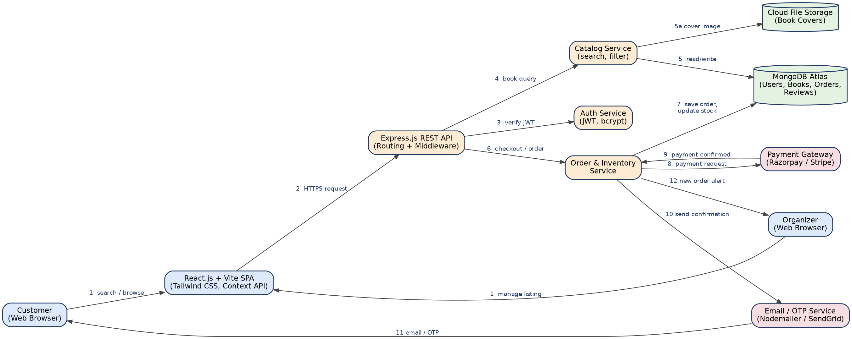
Figure 1: Architecture and data flow of the Bookstore Management System

Data Flow Description
- Customer or organizer interacts with the React.js SPA to search/browse books or manage listings.
- The SPA sends an HTTPS request to the Express.js REST API gateway.
- The gateway verifies the user's JWT via the Auth Service before processing protected requests.
- Book search/browse requests are routed to the Catalog Service.
- The Catalog Service reads/writes book data in MongoDB Atlas and fetches cover images from Cloud File Storage.
- Checkout/order requests are routed to the Order & Inventory Service.
- The Order & Inventory Service saves the order and updates stock levels in MongoDB Atlas.
- A payment request is sent to the external Payment Gateway (Razorpay/Stripe).
- The Payment Gateway confirms successful payment back to the Order & Inventory Service.
- A confirmation is dispatched through the Email/OTP Service.
- The customer receives an email/OTP order confirmation.
- The organizer receives a new-order alert so they can process fulfilment.

Reference: https://aws.amazon.com/blogs/industries/voice-applications-in-clinical-research-powered-by-ai-on-aws-part-1-architecture-and-design-considerations/

